Contents
1 Introduction 3
1.1 Purpose and Scope 3
2 Design Overview 3
3 Detailed Design 6
3.1 ECOM Client API 6
3.2 Resource File and Proxy table 9
3.2.1 Resource File 9
3.2.2 Creation guidelines for the resource file 11
3.2.3 Proxy Table 12
3.2.4 Function Pointer examples (for Get and Release) 13
3.3 ECOM Client Internals 15
3.3.1 Overview 15
3.3.2 UML Diagram 15
3.3.3 Design Unit Behaviour 15
3.3.3.1 CLoadManager 15
3.4 ECOM Server Internals 21
3.4.1 Overview 21
3.4.2 UML Diagram 21
3.4.3 Design Unit Behaviour 21
3.4.3.1 CEComServer 21
3.4.3.2 CEComServerSession 21
3.4.3.3 CRegistryData 22
3.4.3.4 CRegistryResolveTransaction 25
3.4.3.5 CRegistrar 27
3.4.3.6 CSecurePlugin and CSpiPlugin 27
4 Design Considerations 27
4.1 Configurability and impact on Master Codeline 27
4.2 ROM/RAM Memory Strategy 28
4.2.1 ROM Usage 28
4.2.2 RAM usage 28
4.3 Performance considerations 29
4.4 Error condition handling 30
4.5 Robustness issues 30
4.6 Localisation issues 30
4.7 Hardware/Platform assumptions 30
4.8 Compatibility considerations (Binary, Source, Data) 30
4.9 Interoperability considerations 30
4.10 Platform Security 30
4.11 Modularity 30
5 Testing 31
6 Further Information 32
6.1 References 32
6.2 Open Issues 32
6.3 Glossary 32
6.4 Document History 32

Introduction

Purpose and Scope
This document describes the design of EC043, ECOM Interface Compatibility, Extensions and Versioning. This document will cover the changes required to ECOM to support this feature.
The target audience of this document is the TA and engineers within System Libraries, SMG, Test Engineering and the PM responsible for the EC delivery.

Design Overview
The following diagram shows the high level block view of the ECOM components (ECOM Client and ECOM Server) and their interacting components. The ECOM Client, ECOM Server and IIC:ResourceFile are the components to be modified.
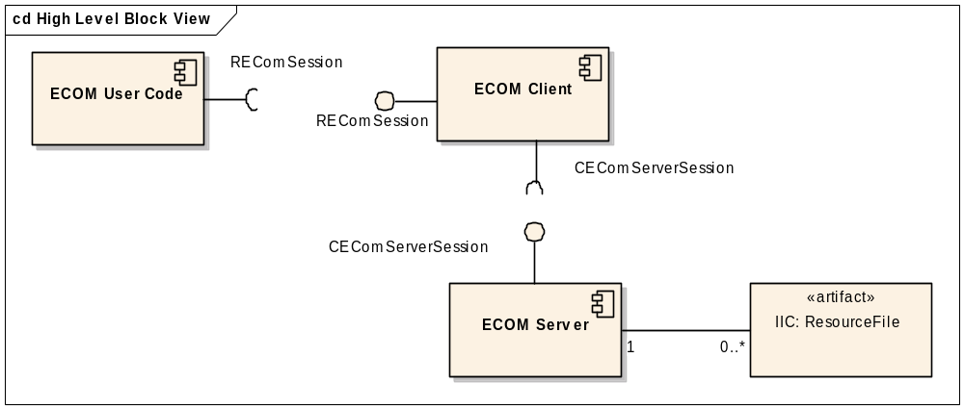
Figure 1 - High Level Block View
The ECOM overview diagram below shows the classes involved in this EC. The classes colored in blue are the classes which are to be modified. Red indicates new classes.
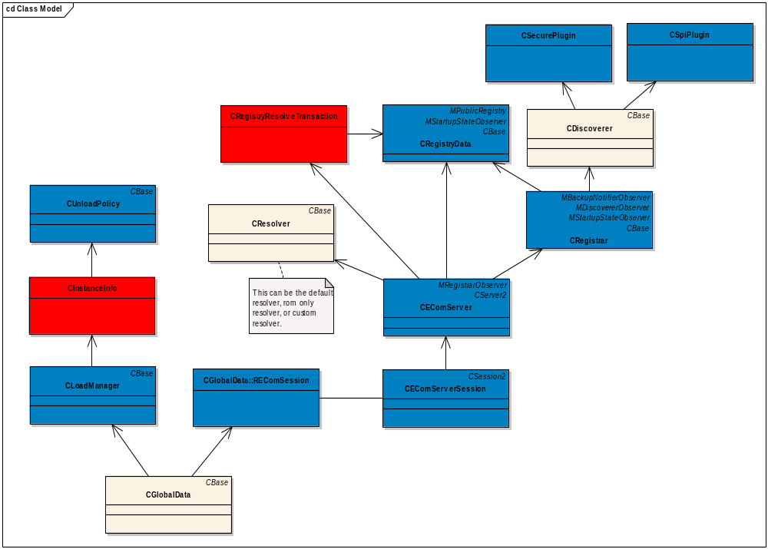
Figure 2 - View of Participating Classes

The following tables describe the participating classes:
Client Classes | Description
REComSession | The REComSession singleton class provides an API to identify (resolution), instantiate, and destroy interface class implementations requested by ECOM clients.
CGlobalData | Controls the life time of a single CEComSession instance and single CLoadManager instance. Uses TLS.
CLoadManager | Manages the loading and unloading of the Interface Implementation Collection (IIC).
CUnloadPolicy | Controls the unloading of implementation groupings

Server Classes | Description
CEComServerSession | Provides the server side session which handles the messages from REComSession
CEComServer | Supplies instantiation & destruction of a class via the ECom framework
CDefaultResolver | Controls the identification, (resolution), of which implementation will be used to satisfy an interface implementation instantiation.
CRegistrar | Responsible for managing Interface Implementation Collection registration (adding and removing entries).
CRegistryData | Manages the entire data of the registry
CRegistryResolveTransaction | Responsible for filtering the registry data. This is used by CResolver.
CDiscoverer | Responsible for locating the IIC present on the file system.

The problem space of this EC is to allow interfaces to be extensible without breaking BC. See /R1/, /R2/, and /R3/ for details about BC and interfaces. This design gets around the BC issues, and allows interfaces to be extensible. To do this, ECOM will introduce the concept of an instantiable interface and an extended interface.
An instantiation interface already exists at the moment for each implementation, but is not marked as such. For sake of distinguishing between interfaces, the following has been defined:
Instantiation Interface – the interface that is returned to the client when an implementation is created
Extended Interface – an interface that extends or expands the functionality of the original instantiation interface
The client will create the instantiation interface as it normally does, using the REComSession::CreateImplementationL methods. A new API will be introduced to allow clients to fetch the extended interfaces. See the diagram below to see how this would work:
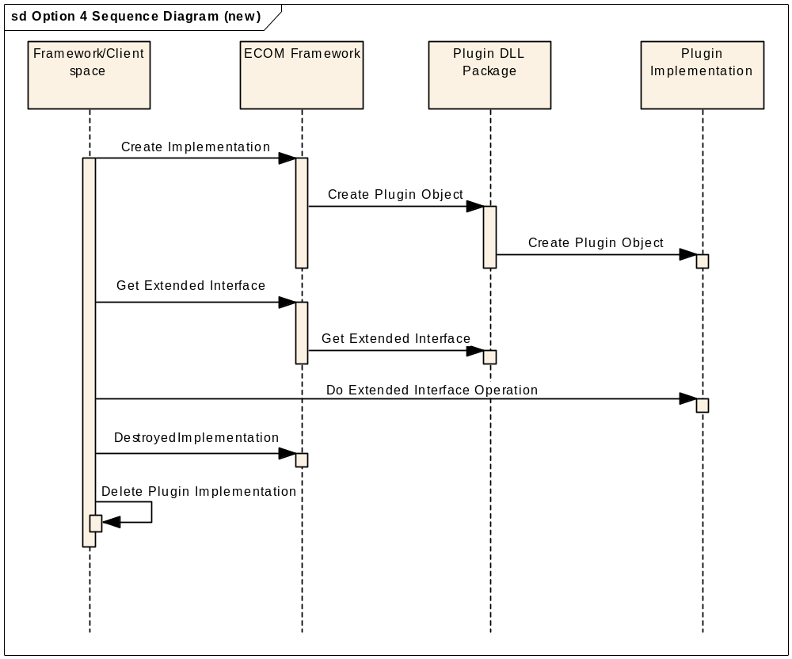
Figure 3 - High level sequence diagram

The framework/client space will create the implementation as normal. Then, when the client wants to fetch an extended interface it will request this extended interface from ECOM itself. The API’s to do this are described in the sections below.
To support the new API’s a new resource file format will be introduced. This will allow plug-in implementers to specify if their particular implementations support a particular extended interface. This is discussed in the sections below also.

Detailed Design

ECOM Client API
Forms the client side of the standard client / server architecture, and exposes the API for access to the set of services provided by the framework. The interface API definition forms the key to providing dynamic resolution and loading of implementations.
REComSession will publish the following new API’s:
class REComSession
{
...

/**
Retrieves a list of all the implementations which satisfy the specified interface, extended interface(s).
@param aInterfaceUid A UID specifying the required interface implementation
@param aExtendedInterfaces Identifies a set of one or more extended interfaces to match. Must match all extended interfaces for a match to occur.
@param aImplInfoArray A reference to a client owned array which will be filled with interface implementation data
*/
IMPORT_C static void ListImplementationsL(TUid aInterfaceUid,
RArray<TUid>& aExtendedInterfaces,
RImplInfoPtrArray& aImplInfoArray);

/**
Retrieves a list of all the implementations which satisfy the specified interface, extended interface(s), with selection restriction to the specified parameters when default resolving
required on the list returned
@param aInterfaceUid A UID specifying the required interface implementation
@param aExtendedInterfaces Identifies a set of one or more extended interfaces to match. Must match all extended interfaces for a match to occur.
@param aResolutionParameters A descriptor specifying any additional implementation characteristics to be fulfilled.
@param aImplInfoArray A reference to a client owned array which will be filled with interface implementation data
*/
IMPORT_C static void ListImplementationsL(TUid aInterfaceUid,
RArray<TUid>& aExtendedInterfaces
const TEComResolverParams& aResolutionParameters,
RImplInfoPtrArray& aImplInfoArray);

/**
Retrieves a list of all the implementations which satisfy the specified interface, extended interface(s), with selection restriction to the specified parameters when custom resolving required on the list returned.
@param aInterfaceUid A UID specifying the required interface implementation
@param aExtendedInterfaces Identifies a set of one or more extended interfaces to match. Must match all extended interfaces for a match to occur.
@param aResolutionParameters A descriptor specifying any additional implementation characteristics to be fulfilled.
@param aResolverUid The CResolver UID which identifies the resolver implementation with the required client defined behavior.
@param aImplInfoArray A reference to a client owned array which will be filled with interface implementation data
*/
IMPORT_C static void ListImplementationsL(TUid aInterfaceUid,
RArray<TUid>& aExtendedInterfaces,
const TEComResolverParams& aResolutionParameters,
TUid aResolverUid,
RImplInfoPtrArray& aImplInfoArray);

/**
Instantiates an interface implementation to satisfy the specified interface and extended interface(s) when default resolving is required. The construction parameters may optionally be provided. Instance key is returned.
@param aInterfaceUid A UID specifying the required interface implementation
@param aExtendedInterfaces Identifies a set of one or more extended interfaces to match. Must match all extended interfaces for a match to occur.
@param aInstanceKey A key uniquely identifying this implementation.
@param aConstructionParameters The parameter structure to pass to the object creation method.
@param aResolutionParameters A descriptor specifying any additional
implementation characteristics to be fulfilled.
@return TAny* A pointer to the instantiated interface implementation.
*/
IMPORT_C static TAny* CreateImplementationL(TUid aInterfaceUid,
RArray<TUid>& aExtendedInterfaces,
TUid& aInstanceKey,
TAny* aConstructionParameters = NULL,
const TEComResolverParams& aResolutionParameters);

/**
Instantiates an interface implementation to satisfy the specified interface and extended interface(s) when custom resolving is required. The construction parameters may optionally be provided. Instance key is returned.
@param aInterfaceUid A UID specifying the required interface implementation
@param aExtendedInterfaces Identifies a set of one or more extended interfaces to match. Must match all extended interfaces for a match to occur.
@param aInstanceKey A key uniquely identifying this implementation.
@param aConstructionParameters The parameter structure to pass to the object creation method.
@param aResolutionParameters A descriptor specifying any additional
implementation characteristics to be fulfilled.
@param aResolverUid The Uid of a CResolver with client defined behaviour.
@return TAny* A pointer to the instantiated interface implementation.
*/
IMPORT_C static TAny* CreateImplementationL(TUid aInterfaceUid,
const RArray<TUid>& aExtendedInterfaces,
TUid& aInstanceKey,
TAny* aConstructionParameters = NULL,
const TEComResolverParams& aResolutionParameters,
TUid aResolverUid);

/**
Instantiates an interface implementation to satisfy the specified interface and extended interface(s) when default resolving is required. The construction parameters may optionally be provided. An offset of the instance key is returned.
@param aInterfaceUid A UID specifying the required interface implementation
@param aExtendedInterfaces Identifies a set of one or more extended interfaces to match. Must match all extended interfaces for a match to occur.
@param aKeyOffset An offset to the 32 bit identifer returned by the ECom framework to identify this instance to the framework.
@param aConstructionParameters The parameter structure to pass to the object creation method.
@param aResolutionParameters A descriptor specifying any additional
implementation characteristics to be fulfilled.
@return TAny* A pointer to the instantiated interface implementation.
*/
IMPORT_C static TAny* CreateImplementationL(TUid aInterfaceUid,
RArray<TUid>& aExtendedInterfaces,
TInt32 aKeyOffset,
TAny* aConstructionParameters = NULL,
const TEComResolverParams& aResolutionParameters);

/**
Instantiates an interface implementation to satisfy the specified interface and extended interface(s) when custom resolving is required. The construction parameters may optionally be provided. An offset of the instance key is returned.
@param aInterfaceUid A UID specifying the required interface implementation
@param aExtendedInterfaces Identifies a set of one or more extended interfaces to match. Must match all extended interfaces for a match to occur.
@param aKeyOffset An offset to the 32 bit identifer returned by the ECom framework to identify this instance to the framework.
@param aConstructionParameters The parameter structure to pass to the object creation method.
@param aResolutionParameters A descriptor specifying any additional
implementation characteristics to be fulfilled.
@param aResolverUid The Uid of a CResolver with client defined behaviour.
@return TAny* A pointer to the instantiated interface implementation.
*/
IMPORT_C static TAny* CreateImplementationL(TUid aInterfaceUid,
const RArray<TUid>& aExtendedInterfaces,
TInt32 aKeyOffset,
TAny* aConstructionParameters = NULL,
const TEComResolverParams& aResolutionParameters,
TUid aResolverUid);

/**
Retrieve a list of all extended interfaces for the provided implementation.
@param aImplementationUid Specifies the implementation to fetch extended interfaces for.
@param aIfInfo Populated list of interfaces
*/
IMPORT_C static void REComSession::ListExtendedInterfacesL(TUid aImplementationUid,
RArray<TUid>& aIfInfo)

/**
Fetches an interface from a specified plug-in instance. NULL if it does not exist
@param aInstanceKey A key specifying a previously created implementation.
@param aExtendedInterfaceUid Identifies an interface to fetch from the plug-in instance.
@return TAny* A pointer to the interface implementation.
*/
IMPORT_C static TAny* REComSession::GetExtendedInterfaceL(TUid aInstanceKey, TUid aExtendedInterfaceUid);

/**
Releases the extended interface associated with the supplied instance. It would be used optionally to clean up an extended interface before automatic cleanup occurs when instance
destroyed. Interface designer may decide the type of the extended interface to be transient interface, which requires clients to use this API for release, or to be permanent interface, which will be released by ECOM.
@param aInstanceKey A key specifying a previously created implementation.
@param aExtendedInterfaceUid Identifies the interface to free from the plug-in instance.
*/
IMPORT_C static void REComSession::ManuallyReleaseExtendedInterfaceL(TUid aInstanceKey, TUid aExtendedInterfaceUid);

}

The ListImplementationsL API’s above allow the extended interfaces to be a selection criterion.
The CreateImplemenationsL API’s above allow the extended interfaces to be a selection criteria.
The ListExtendedInterfacesL API is meant to allow the client to list the extended interfaces of a specified implementation. This allows the client to list interfaces when already working with a specific implementation.
The GetExtendedInterfaceL API is to allow clients to fetch extended interfaces of a previously created implementation.
The ManuallyReleaseExtendedInterfaceL API is to allow clients to manually release an extended interface. Interface designer can decide the type of the extended interface to be a transient interface, which may require clients to use this API for release, or to be a permanent interface, which will be released by ECOM. Normally, the extended interfaces would be automatically cleaned up by ECOM when the REComSession::DestroyedImplementation is called. This API allows for more precise control over the extended object’s lifetime if there is a need to clean up the extended object earlier.
Note that the CreateImplementationL and the GetExtendedInterfaceL are kept as separate interfaces to ensure that it is understood that extended interfaces do not exist on their own (if they were merged as one operation, it would be confusing as two interface pointers would have to be returned to the client, one for the main instantiation interface and the other for the extended interface). Once the client determines and creates the appropriate implementation it is possible to fetch the extended interfaces. It is not possible to create an extended interface directly with the CreateImplementationL() methods, as extended interfaces require that the main instantiation interface be created first.

Resource File and Proxy table
The resource file and proxy tables allow plug-in implementers to publish their Interface Implementation Collection (IIC).

Resource File
In the previous versions of resource files each implementation supported one interface. Now, each interface supports one main interface (as before), but now also supports extended interfaces. To support this, a new resource file format will be introduced. For ease of transition and lower risk, the current format was kept as much as possible, with the addition of the extended interface concepts.
Here is the new resource file format. See the bold text for new additions or changes to the resource file.
#define ImplementationInfoRecordType1 1

STRUCT IMPLEMENTATION_INFO
{
BYTE info_format; // ImplementationInfoRecordType1
LONG implementation_uid;
BYTE version_no;
LTEXT display_name;
LEN BYTE LTEXT8 default_data[];
LEN BYTE LTEXT8 opaque_data[];
LONG extended_interfaces[];
BYTE flags; // #define flag_rom_only 0x01 etc.....
}

#define ImplementationInfoRecordType2 2

STRUCT BINARY_IMPLEMENTATION_INFO
{
BYTE info_format; // ImplementationInfoRecordType2
LONG implementation_uid;
BYTE version_no;
LTEXT display_name;
BYTE default_data[];
BYTE opaque_data[];
LONG extended_interfaces[];
BYTE flags; // #define flag_rom_only 0x01 etc....
}

STRUCT INTERFACE_INFO
{
LONG instantiation_interface_uid;
STRUCT implementations[];
}

// This defines the REGISTRY_INFO and INTERFACE_INFO structures together.
#define RESOURCE_FORMAT_VERSION_3 0xE9000014

STRUCT REGISTRY_INFO
{
LONG resource_format_version; // RESOURCE_FORMAT_VERSION_3
LONG dll_uid;
STRUCT interfaces[];
}

To explain the field additions:
resource_format_version - the new resource format will be known as version three. (ECOM would continue to support the previous resource file formats for backwards compatibility). Note that resource format version three must be used with the dll type PLUGIN3 only. It cannot be used for the original plug-in dll, since extended_interfaces are meaningless for the original plug-in dll, and would only cause confusion if the new resource format were to be used with the original plug-in dll. This will be enforced in ECOM server. See the ECOM Server section 3.4.3.6 for more details.
info_format – identifies the type of info record. This will be used to identify the record itself. Will start from 1 and will be incremented for every new release of a record. All records have the info_format field, allowing any record to be modified without changing the resource format version.
flags – will contain flags marking features. At first it will only contain the rom_only field.

// Flags field bit masks (to be defined in RegistryInfoV3.rh)
#define IMPLEMENTATION_INFO_FLAG_ROM_ONLY 0x01
… more masks to be introduced in the future

default_data, opaque data – will have new structures allowing more data to be stored.
The IMPLEMENTATION_INFO structure will have an array of LTEXT8 types, with a one byte length field (which means a maximum of 255 elements in the array). Also each LTEXT8 element has a one byte length field, so each LTEXT8 field can be a maximum of 255 bytes. Currently, it has been limited to a maximum of 2 elements in the array.
The BINARY_IMPLEMENTATION_INFO structure will allow a two byte length field, allowing up to 65535 bytes. Currently, it has been limited to a maximum of 512 bytes.
instantiation_interface_uid – publishes what interface is instantiated when the plug-in object is created
extended_interfaces - publishes which extended interfaces are available for this implementation
An example of how it would look is below. The following resource file represents two implementations, each having one instantiation interface, which is captured in the instantiation_interface field. This has been renamed from interface_uid to be clear that this is the instantiation interface (as defined earlier). The validation implementation has extended interfaces as well, these are captured in the extended_interfaces field. See the bold text for new additions or changes to the resource file.

#include "101F446E.rls"
#include "Ecom/RegistryInfoV3.rh"

RESOURCE REGISTRY_INFO theInfo
{
resource_format_version = RESOURCE_FORMAT_VERSION_3;
dll_uid = 0xE9000100;
interfaces=
{
INTERFACE_INFO
{
instantiation_interface_uid = 0x10009DBB;
implementations =
{
IMPLEMENTATION_INFO
{
info_format = IMPLEMENTATION_INFO_RECORD_TYPE1;
implementation_uid = 0xE9000101;
version_no = 1;
display_name = "Example Plugin No. 10"
default_data = {"example text – can be up to 255 bytes"," example text, part 2 – can be up to 255 bytes "};
opaque_data = {" example text – can be up to 255 bytes ",” example text, part 2, can be up to 255 bytes “};
extended_interfaces = {0x101FAAAA, 0x101FAAAB};
flags = IMPLEMENTATION_INFO_FLAG_ROM_ONLY;
},
BINARY_IMPLEMENTATION_INFO
{
info_format = IMPLEMENTATION_INFO_RECORD_TYPE2;
implementation_uid = 0xE9000102;
version_no = 1;
display_name = "Example Plugin No. 10";
default_data = { 0x1B, 0x50, 0x1F, 0x10 };
opaque_data = { 0x1B, 0x50, 0x1F, 0x10 };
extended_interfaces = {};
flags = IMPLEMENTATION_INFO_FLAG_ROM_ONLY;
}
};
},
};
}

Creation guidelines for the resource file
Here are the guidelines that should be followed when creating the new resource file:
- Restriction of only one instantiable interface per implementation.
- All other interfaces in the implementation are extension interfaces, with the following properties:
  - Identified by a globally unique UID that identifies the extended interface
  - Provides an interface by either one of the following mechanisms:
1) Is a static re-cast of the original plug-in object
OR
2) Is a newly created object
- Due to the resource compiler not fully supportting the new format of the resource file ,some temporary maximum tested values are recommended.
- Maximum 4 INTERFACE_INFO in one resource file
- Maximum 8 IMPLEMENTATION_INFO or BINARY_IMPLEMENTATION_INFO (total not to exceed 8 for both) in each INTERFACE_INFO
- Maximum 8 extended interfaces in each implementation
- In IMPLEMENTATION_INFO, maximum 2 strings with 255 bytes each for default_data or opaque_data.
- In BINARY_IMPLEMENTATION_INFO, maximum 512 bytes each in default_data or opaque_data.
- The maximum number of extended interfaces in one implementation is 8.

To provide an interface using mechanism 1) a static re-cast of the original plug-in object means that the extended interface uses an inheritance relationship with the original plug-in class interface to provide the extended interface. That is, the original plug-in class interface is also of the type that is defined by the extended interface. In terms of clean-up, no extra clean up is required. When the main plug-in object is deleted the extended interface will be deleted also, as it is part of the main plug-in object itself.
To provide an interface using mechanism 2) a new object is a completely separate and new object that provides the extended interface. This object must be cleaned up. This can be accomplished by using the ECOM framework’s Release mechanism. See section 3.2.4 for more details, including examples of the get and release functions and the details of the automatic release flag.

Proxy Table
The proxy table needs to be modified to support fetching of the extended interfaces. Since the proxy table is the single exported method of the DLL, and will be changing a new DLL type is required. With this new dll comes a new second UID to identify the DLL type. The new dll type is known as PLUGIN3 and provides the following signature and proxy table:

EXPORT_C const TImplementationProxy3* ImplementationGroupProxy(TInt& aTableCount)
{
aTableCount = sizeof(KImplementationTable) / sizeof(TImplementationProxy3);
return KImplementationTable;
}

const TImplementationProxy3 KImplementationTable[] =
{
IMPLEMENTATION_PROXY_ENTRY3(0xE9000101, CPluginExample1::NewL, CPluginExample1::GetExtendedInterface, CPluginExample1::ReleaseExtendedInterface),
IMPLEMENTATION_PROXY_ENTRY3(0xE9000102, CPluginExample2::NewL,0,0)
IMPLEMENTATION_PROXY_ENTRY3(0xE9000103, CPluginExample3::NewL, CPluginExample3::GetExtendedInterface, 0),
};

The proxy table macro takes in the implementation UID and the instantiation interface as the previous macro did. The two new columns in the table are the columns which specify the function pointer to fetch the extended interface and the function pointer to release the extended interface.
Note that the proxy table above has three different entries. The first entry shows an interface that has support for getting and releasing extended interfaces. The second entry does not support extended interfaces at all, so the get and release function pointers are blank. The third entry supports extended interfaces but does not require release to be called on any of the extended interfaces. In the case that some extended interfaces require a release, then a release function pointer must be defined. That is when the release flag is used, to indicate which extended interfaces need to be released.

Note that TImplementationProxy3 is defined as:

typedef struct
{
// The unique UID for an Interface Implementation
TUid iImplementationUid;
// The function pointer to the instantiation method
TProxyNewLPtr iNewLFuncPtr;
// The function pointer used to fetch extended interfaces
TProxyExtendedInterfaceGetPtr iFuncPtrGetInterface;
// The function pointer used to release the extended interfaces
TProxyExtendedInterfaceReleasePtr iFuncPtrReleaseInterface;
// reserved for future proofing
TInt32 iReserved1;
TInt32 iReserved2;
TInt32 iReserved3;
TInt32 iReserved4;
} TImplementationProxy3;

The implementation proxy structure has two new entries for the get and release function pointers. The final entry is left empty for future use. The associated macro is defined as follows:

define IMPLEMENTATION_PROXY_ENTRY3(aUid, aFuncPtr, aGetExtFuncPtr, aReleaseExtFuncPtr) {{aUid},(TProxyNewLPtr)(aFuncPtr),( aGetExtFuncPtr),( aReleaseExtFuncPtr),0,0,0,0}

Note, TProxyExtendedInterfaceGetPtr is defined as a function pointer as follows:

typedef TAny* (*TFuncPtrGet)(TAny*,TUid,TUint32&,TAny*&);
typedef TFuncPtrGet TProxyExtendedInterfaceGetPtrL;

And TProxyExtendedInterfaceReleasePtr is defined as a function pointer as follows:

typedef void (*TFuncPtrRelease)(TAny*,TUid);
typedef TFuncPtrRelease TProxyExtendedInterfaceReleasePtr;

See the next section for examples of how to use the constructs defined above.

Function Pointer examples (for Get and Release)
In the proxy table above GetExtendedInterface is a function pointer used to return the appropriate extended interface. The function pointer to get the extended interface must use the TproxyExtendedIntGetPtr signature. Here is an example of how this function could be defined:
TAny* CImplementationClassTen::GetExtendedInterfaceL(TAny* aObject,TUid aInterface,TUint32& bitFlags, TAny*& releaseObject)
{
TAny* ret = NULL;
switch (aInterface.iUid)
{
case 0x101FAAAA:
{
// No release is required, so do not modify bitFlags.
ret = static_cast<MExampleInterfaceExtended *>(static_cast<CImplementationClassTen *>(aObject));
}
case 0x101FAAAB:
{
bitFlags = bitFflags | KReleaseRequiredMask; // Indicate to ECOM that release is required
CImplementationClassTenExtended *classExt = CImplementationClassTenExtended::NewL();
// Must set the release object for ECOM to release later, this will not be the same as the interface object that is returned.
releaseObject = classExt;

ret = static_cast<MExampleInterfaceExtended2*>(classExt);
}
}
return ret;
}

For further details of this example, please see the sample plug-in and the how to documentation. All functions used to fetch extension methods MUST contain the parameter types in the same order as in the GetExtendedInterface method above. This is enforced by the TProxyExtendedInterfaceGetPtrL function pointer (defined earlier). The aObject parameter is supplied by ECOM, the TUid parameter is supplied by the user via this method:

IMPORT_C static TAny* REComSession::GetExtendedInterfaceL(TUid aInstanceKey, TUid aInterfaceUid);

The bitFlags field will be used for signaling between ECOM and the plug-in implementations. Initially the bitFlags will only use one bit, which will be used for notifying ECOM if the extended interface requires a release call to clean up resources. The bit mask for this setting will be defined in ImplementationProxy.h as follows:

// Get extended interface bit masks.
const TUint32 KReleaseRequiredMask = 0x00000001;
… more masks to be introduced in the future

If this bit above is set within the GetExtendedInterface call in the plug-in implementation, then the release function pointer will be called.
If the release function pointer will be called then the releaseObject parameter is required to be populated by the plug-in implementer. This should be set to the object that is created for the extended interface (which is not the same as the interface pointer that is returned).
Plug-in implementers have the option of automatic or manual release of extended objects. If the automatic release is desired, then this can be achieved by indicating that this object requires automatic cleanup via a flag in the get extended interface function. Automatic release takes place when the main interface object is destroyed. At this time all interfaces that have been marked for release will have one call to the release function pointer for each interface to be released. When release is called the plug-in implementer should do any cleanup within the release function.
If a manual release is desired than this is accomplished by calling REComSession::ManuallyReleaseExtendedInterface. Note that the release flag should still be set, in case the manual release is not executed due to a pre-mature destruction of the main implementation object. When the manual release is executed the release function pointer is immediately called.
The function pointer to release the extended interface must use the TProxyExtendedInterfaceReleasePtr signature, and an example is shown here:
void CImplementationClassTen::ReleaseExtendedInterface(TAny* aObject,TUid aInterface)
{
switch (aInterface.iUid)
{
case 0x101FAAAB:
{
// this object is an interface that was a separate object from the main instantiated object, and must be cleaned up.
CImplementationClassTenExtended* classExt = static_cast<CImplementationClassTenExtended*>(aObject);
delete classExt;
}
}
}

When the release function pointer is called the cleanup will be determined by the plug-in implementer as shown above. Notice in the example above that the interface that had been previously marked with the bit flag will have its’ resources released, whereas the other interface has nothing to release, so release is not even called, and hence there is no need for checking for that interface in the release function case statement.
Note that if any initialization is required for the extended interfaces, then the extended interface itself should supply an initialization method which should be called after the interface is returned from the REComSession::GetExtendedInterfaceL call. That is, no initialization parameters can be passed through the REComSession::GetExtendedInterfaceL method.

ECOM Client Internals

Overview
The new API’s will be implemented in this component.

UML Diagram
Blue indicates classes that are to be modified. Red indicates new classes.
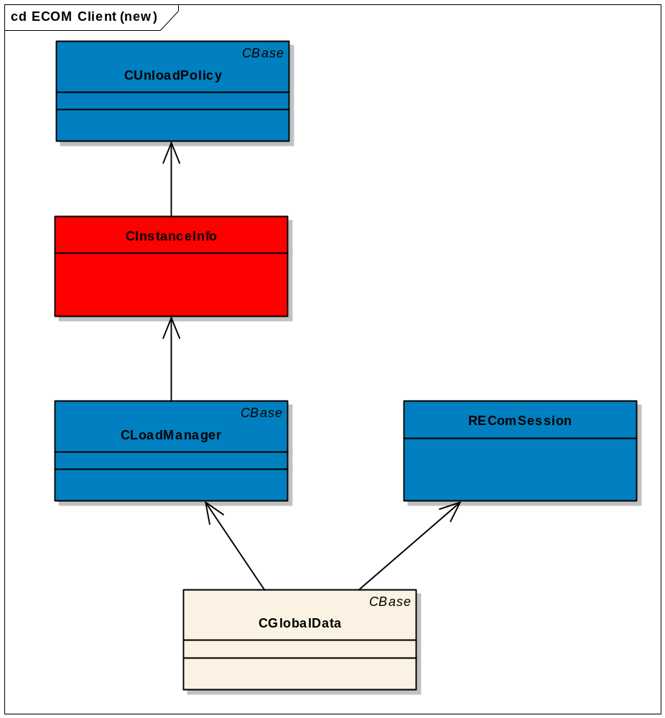
Figure 4 - ECOM Client Class Diagram

Design Unit Behaviour

CLoadManager
The Load Manager will be modified to support extended interfaces. Currently when an implementation is created destruction key is provided to the client. The client then calls REComSession::DestroyedImplementation() after the plug-in object is destroyed.
Currently the destruction key is always the implementation UID. This will be changed to be a unique identifier so that it can be used for purposes of uniquely identifying each implementation (it is possible to have multiple plug-in instances of one implementation).
The instance identifier will be the address of the CInstanceInfo object itself. This address will be unique across the thread.
See BR2209 - Internal ECOM implementation handle (aDtorIDKey in APIs) values changed
Considering multiple threads, the objects are uniquely identified by the fact that they are in different threads. It has always been a restriction of ECOM that an implementation must be created and destroyed within the same thread. This is due to the usage of the unload policy array in CLoadManager.
This component will have the new responsibility to manage plug-in object information. This will be maintained in an array.

Data
After the plug-in object is instantiated in the Load Manager the following information will be stored in this data structure:

class CInstanceInfoExtended: public CInstanceInfo
{
public:
...

static CInstanceInfoExtended* NewL(CUnloadPolicy* aUnloadPolicy,const TImplementationProxy3* aRow);
void SetObject(TAny* aImplementationObject);
~CInstanceInfoExtended (); // Release all extended objects (if not already released)

TUid ImplementationUid() {return iImplementationProxyRow->iImplementationUid;};
TProxyExtendedInterfaceGetPtrL ProxyExtendedIntGetPtr() {return iImplementationProxyRow->iFuncPtrInterfaceGetL;};
TProxyExtendedInterfaceReleasePtr ProxyExtendedIntReleasePtr() {return iImplementationProxyRow->iFuncPtrInterfaceRelease;};
TAny* CreateExtObjectL(TUid aExtendedInterfaceUID);
void DestroyExtObject(TUid aExtendedInterfaceUID);
TAny* ImplementationObject() {return iImplementationObject;};
private:
// Pointer to proxy implementation table row entry that this instance corresponds to.
// This is where the implementation UID, get and release extended interface function
// pointers reside.
TImplementationProxy3* iImplementationProxyRow;
// The instantiation interface object for the dll which contains this implementation
TAny* iImplementationObject;
// The created extended object information structure.
struct TExtendedObjectInfo
{
// The extended interface UID
TUid iExtendedInterfaceUID;
// The extended interface object for the this implementation
TAny* iExtendedInterfaceObject;
};

// List of all of the created extended objects for this implementation
RArray<TExtendedObjectInfo> iExtendedObjectInfo;

private:
CInstanceInfoExtended(CUnloadPolicy* aUnloadPolicy,const TImplementationProxy3* aImplementationProxyRow);
...

};

class CInstanceInfoSimple: public CInstanceInfo
{
...

public:
static CInstanceInfoSimple* NewL(CUnloadPolicy* aUnloadPolicy,const TImplementationProxy* aImplementationProxyRow);
public:
TUid ImplementationUid() {return iImplementationProxyRow->iImplementationUid;};
// The following functions are not required for CInstanceInfoSimple.
// PLUGIN1 type is not meant to extend interfaces.
TProxyExtendedInterfaceGetPtrL ProxyExtendedIntGetPtr(){return NULL;};
TProxyExtendedInterfaceReleasePtr ProxyExtendedIntReleasePtr(){return NULL;};
TAny* CreateExtObjectL(TUid /*aExtendedInterfaceUID*/) {return NULL;};
void DestroyExtObject(TUid /* aExtendedInterfaceUID*/) {};
TAny* ImplementationObject() {return NULL;};

private:
CInstanceInfoSimple(CUnloadPolicy* aUnloadPolicy,const TImplementationProxy* aImplementationProxyRow);

private:
// Pointer to proxy implementation table row entry that this instance corresponds to.
// This is where the implementation UID resides.
const TImplementationProxy* iImplementationProxyRow;
...

};

class CInstanceInfo : public CBase
{
public:
virtual ~CInstanceInfo() = 0;
CUnloadPolicy* UnloadPolicy() {return iUnloadPolicy;};
public:
virtual TUid ImplementationUid() = 0;
virtual TProxyExtendedInterfaceGetPtrL ProxyExtendedIntGetPtr() = 0;
virtual TProxyExtendedInterfaceReleasePtr ProxyExtendedIntReleasePtr() = 0;
virtual TAny* CreateExtObjectL(TUid aExtendedInterfaceUID) = 0;
virtual void DestroyExtObject(TUid aExtendedInterfaceUID) = 0;
virtual TAny* ImplementationObject() = 0;
protected:
CInstanceInfo(CUnloadPolicy* aUnloadPolicy);
private:
// The Unload Policy for the dll which contains this implementation
CUnloadPolicy* iUnloadPolicy;
};

// Array of instance information
RPointerArray<CInstanceInfo> iInstanceInfoList;

The CInstanceInfo class is the base class for instance info management. The derived classes were broken into simple and extended for memory usage efficiency when working with simple objects (they don’t need all of the attributes that extended does). This class defines virtual methods for accessing the data from the sub-classes.

The iUnloadPolicyMapping array will be merged into the CInstanceInfo array, as the data that they contain overlaps. So, the CInstanceInfo array will contain the attributes that were originally in the iUnloadPolicyMapping array (version of the implementation and the unload policy).

In CInstanceInfoSimple, the proxy table entry of type TImplementationProxy is stored, which contains the implementation UID, and the function pointer to create the implementation.

In CInstanceInfoExtended, the proxy table entry of type TImplementationProxy3 is stored, which contains the implementation UID, the function pointer to create the implementation, and the function pointers to get and release the extended interfaces.

The instantiation interface object is the object pointer created when the instantiation interface is created, and is saved for use when getting an extended interface.

The extended object information is stored for the purposes of releasing the extended interface objects in the future. It will be populated by extended interfaces that need to be released.

Operations
In terms of operations, when a request is made to fetch an extended interface, CLoadManager will take the instance identifier key and reinterpret_cast the key into a CInstanceInfo pointer. If the wrong pointer is passed in then a panic will occur. Using this pointer it has direct access to the correct CInstanceInfo object, therefore no searching for this item in the array of CInstanceInfo objects is required. Then using the parameters from the CInstanceInfo object, the function pointer to get the extended interface is used to fetch the extended interface. This will result in the call of the “GetExtendedInterfaceL()” method supplied by the plug-in. The plug-in would be responsible for returning the extended interface object being requested. This pointer would then be returned back to the client. Additionally, if the extended interface needs to be released a TExtendedObjectInfo entry will be created and added to the iExtendedObjectInfo array containing the extended interface pointer and its’ interface UID.
If an implementation is destroyed, CLoadManager will clean up the appropriate implementation instance in the instance info array (unlike the older cleanup done by the iUnloadPolicyMapping array which cleaned up each element at the end, cleanup will be immediate). During the clean-up, the extended object information array within the implementation instance will be used to clean up each extended interface instance. The array will be traversed, and for each extended interface element in the array a Release(aObject, aInterface) call will be made to clean up the extended object.
Then, the CInstanceInfo object will be removed from the instance array. A linear search through the array will be performed to find the CInstanceInfo object. The match will be based on the CInstanceInfo address.

Please see the sequence diagram below, containing the implementation creation mechanism, fetch of an extended interface, and destruction.
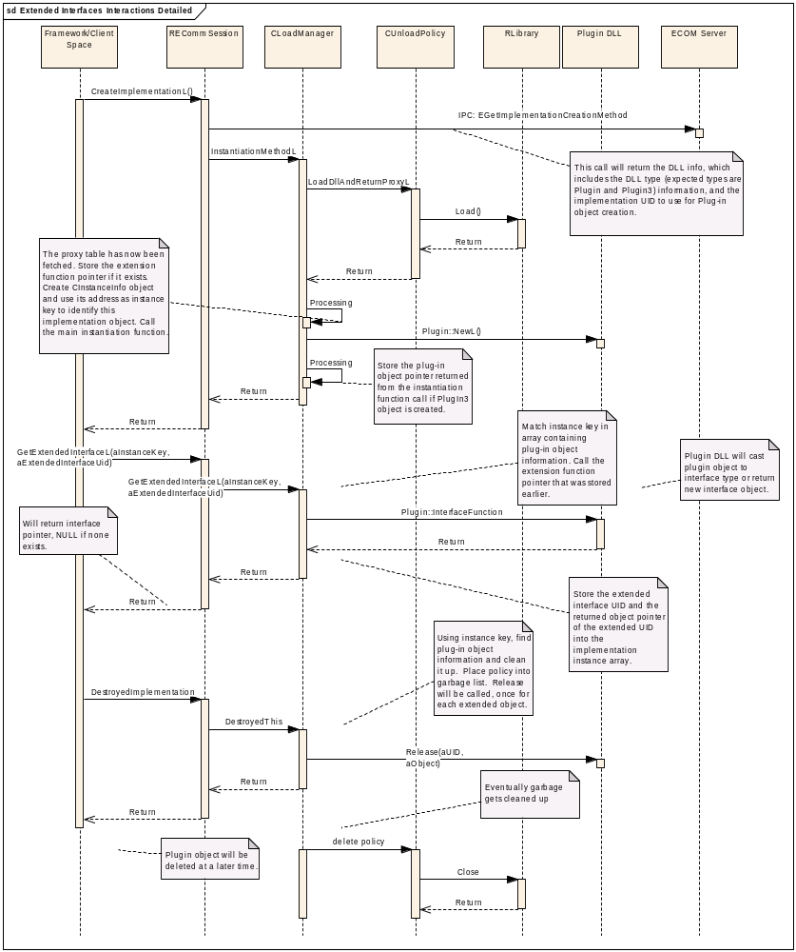
Figure 5 - Creation, Fetch Extended Interface, Destruction
For manual release, the interface that is being released will be matched and deleted in the extended interface release array within the CInstanceInfo object. This is done so the manually released interface does not get released in the automatic release mechanism process later on. See the diagram below which shows how manual release works:
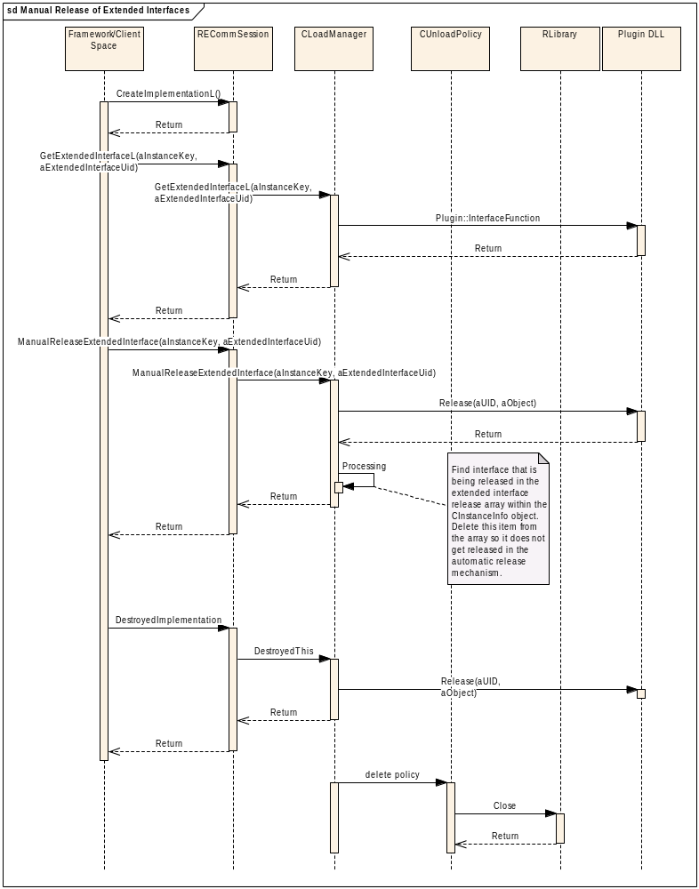
Figure 6 - Manual Release of Extended Interfaces

ECOM Server Internals

Overview
The server side of the framework exists to provide controlled access to a single instance of the registry data.

UML Diagram
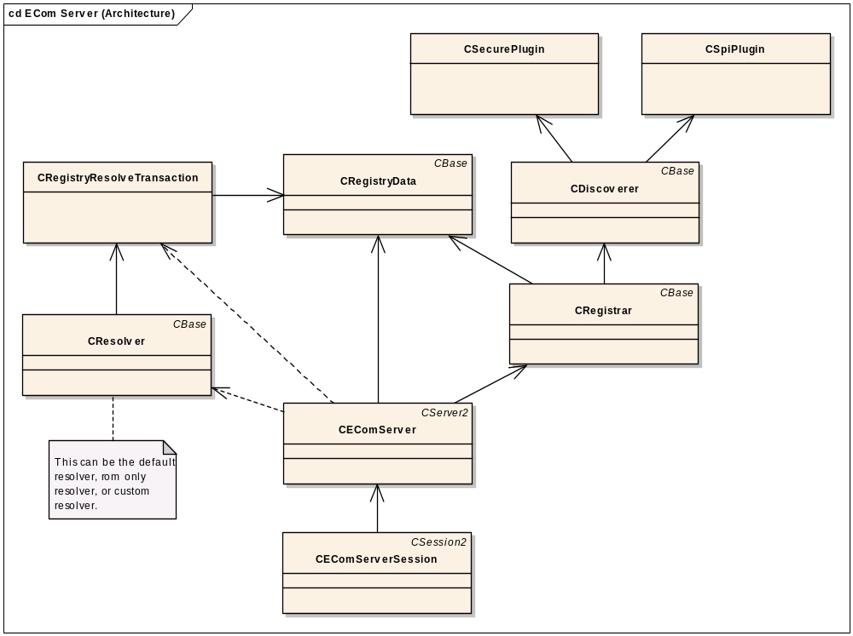
Figure 7 - ECOM Server Class Diagram
A new class has been added, CRegistryResolveTransaction, this is used by CResolver to fetch a list of implementations from CRegistryData and filter the list base on the capability and extended interfaces check. Classs to be modified are CEComServer, CEComServerSession, CRegistryData, CRegistrar, CSecurePlugin, and CSpiPlugin.

Design Unit Behaviour

CEComServer
Supporting code modifications to handle the new REComSession API’s (pass through code, message handling). CEComServer::GetSecuredPolicedListL will be removed, as post filtering is not needed anymore. The CEComServer ListImplementationsL and GetResolvedDllInfoL methods will take in a new parameter (TClientRequest aMessage) to allow for security filtering.

CEComServerSession
Supporting code modifications to handle the new REComSession API’s (pass through code, message handling).

CRegistryData
CRegistryData will be responsible to store the extended interface tables. CRegistryData contains the data structures that map data from the resource files into the registry. Support is required to fetch the list of extended interfaces quickly, also the new resource file format requires additional support in the drive data structure.
At the moment the registry data has three ways of viewing the data:
- Drive structure view. This form is the registration set represented by Drive->Dll’s->Interfaces->Implementations contained therein. It is broken into ‘branches’ with each available drive containing the ‘branch’ for the registered interface implementations upon that drive.
This EC will require additions to the drive structure view to model the resource file structure. The CImplementationData class will now have ownership of the extended interface being an array of TUid’s.
- Indexing view based on the registered implementation UID. This is needed for fast access. This view is used to quickly fetch the implementation to handle a CreateImplementationL() call in which the implementation is specified only. It contains a sub-set of the full registry data. Allows support for this interface:

IMPORT_C static void REComSession::ListExtendedInterfaces(TUid aImplementationUid,
RArray<TUid>& aIfInfo)
- Indexing view based on the registered interface UID. This is needed for fast access. This view is used to determine which implementations are registered and available for instantiation whilst the server is running. It contains a sub-set of the full registry data. Allows support for ListImplementationsL and CreateImplementationL.
The new class diagram is shown below. Classes to be modified are shown in blue.
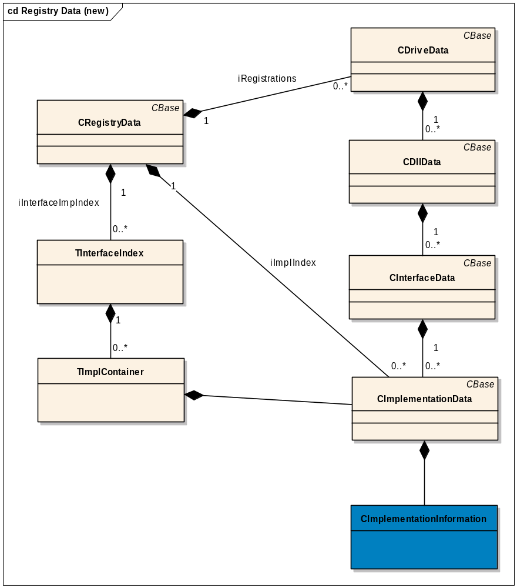
Figure 8 - CRegistryData architecture (new)
CImplementationInfo will contain a pointer points to the array of TUid’s each containing the extended interface that this implementation contains, and will have the following new API’s:

NONSHARABLE_CLASS(CImplementationInformation) : public CBase
{
public:
…
// Internal only
void AddExtendedInterfaceL(TUid aExtendedInterface);
RExtendedInterfacesArray* GetExtendedInterfaceList();
…
public:
…
// Can be used by ECOM clients
IMPORT_C void GetExtendedInterfaceListL(RExtendedInterfacesArray& aList);
…
private:
// Array of extended interfaces.
RExtendedInterfacesArray* iExtendedInterfaceList;
…

The GetExtendedInterfaceListL can use IMPORT_C. It will be published by the ECOM client DLL, so if clients wish to use this API they must link to ECOM.DLL. Older clients that are not using this API are not affected, so there is no compatibility break. In particular if custom resolvers wish to use this new API they must link to ECOM.DLL, as in the past custom resolvers did not typically link to this DLL (all methods were previously inline).

The GetExtendedInterfaceList will return the pointer of the extended interface array. It is used internally for ECOM.

As stated above the indexing view based on the registered implementation UID will be used to fetch the extended interface list given an implementation UID. See the sequence diagram below. This will fetch the extended interfaces published by one implementation.
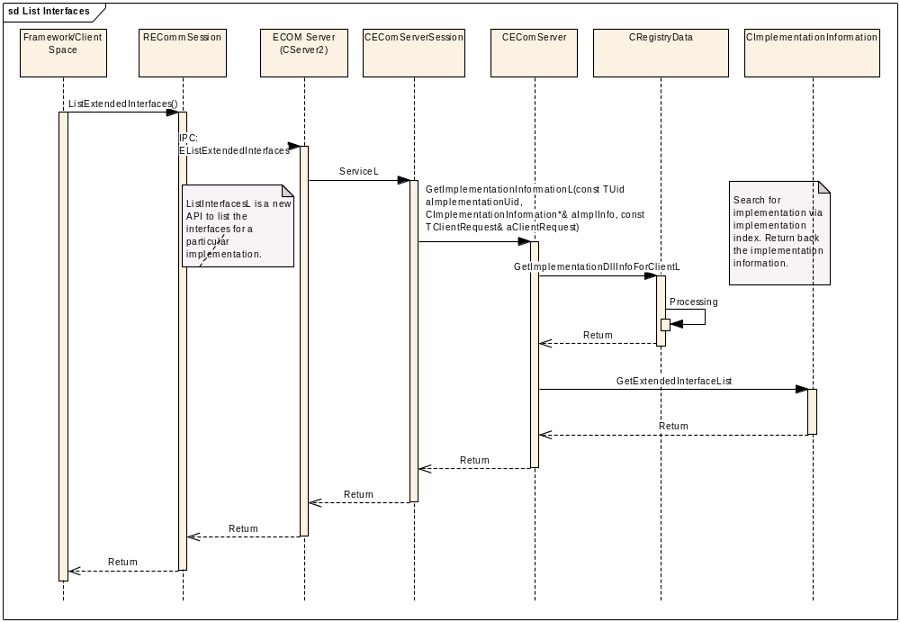
Figure 9 - Fetch extended interface(s) for one implementation
To handle ListImplementationsL, CreateImplementationsL matching implementations given an interface UID and the extended interface UIDs would require use of the new class CRegistryResolveTransaction. This new class is described in the next section. The new class provides transaction facilities to allow filtering based on the extended interface UIDs and the capability parameters. VendorID is set here as well. The interface Uid filtering and SID and DLL UID2 security checks are done by CRegistryData.
This class will be modified so that it is no longer of type MPublicRegistry, as the CRegistryResolveTransaction class will now handle the MPublicRegistry::ListIImplementationsL requests.
CRegistryData::GetCapabilityFilteredListL will be removed, as post filtering is not needed anymore. The member iImplementationInfo1 will be removed as the CRegistryResolveTransaction class will now hold the array containing the final filtered list.
The class will contain a new ListImplementationsL which replaces the old one. The new function returns CImplementationData array instead of CImplementationInformation array and will provide filtering based on filter criteria. Here is the class:

class CRegistryData : public CBase, public MStartupStateObserver
{
public:

…
//Lists the implementations given the interface UID. The filtered list is returned in the client provided RImplDataArray parameter.
void ListImplementationsL(TUid aInterfaceUid, RImplDataArray& aImplementationData) const;

…

Since this EC requires a new DLL type with a corresponding new UID2, this class will validate the UID2 of the dll and resource file format match. This check will be done in the CRegistryData::CDllData::SaveSecurityInfoL method via CRegistryData::CDllData::ProcessSecurityCheckL during a ListImplementationL operation, and also the CRegistryData::ValidateRegistryL operation when discovery is complete. Any mismatch will be logged, and EFalse will be returned from SaveSecurityInfoL.

CRegistryResolveTransaction
This class facilitates filtering base on the extended interface UIDs and TClientrequest parameter passed in when the resolve transaction object is created. During the course of the resolution these filter parameters will be used to filter the implementation data list returned from CRegistryData. The CRegistryResolveTransaction class instance will be created as needed for List Implementation or Create Implementation. It is created before the resolver object because the resolver object requires a handle to the registry. The Default resolver and ROM only resolver will not be created when CEComServer is constructed. They become transient, the same as the customer resolver.
This class will have the same interface as CRegistryData originally had (MPublicRegistry). The resolver objects will now get a pointer to this object instead of the CRegistryData object. The pointer to CRegistryData will be provided to CRegistryResolveTransaction when CRegistryResolveTransaction is constructed.
The CRegistryResolveTransaction has been introduced to reduce code bloat in CRegistryData and ensures that unfiltered implementations are no longer returned to the resolver. It also avoids publishing a public handle to CRegistryData, and allows filters to be added/extended without impacting the registry itself.
The class will look as follows:

class CRegistryResolveTransaction : public CBase, public MPublicRegistry
{
public:
static CRegistryResolveTransaction* NewL(CRegistryData &aRegistryData, const RExtendedInterfacesArray& aExtendedInterfaces, const TClientRequest& aClientRequest);
virtual ~CRegistryResolveTransaction();
public:
RImplInfoArray& ListImplementationsL(TUid aInterfaceUid) const;

private:
CRegistryResolveTransaction(CRegistryData &aRegistryData,const RExtendedInterfacesArray& aExtendedInterfaces, const TClientRequest& aClientRequest);

private:
// A reference to the registry data
CRegistryData &iRegistryData;
// A pointer to the extended interfaces to filter on
const RExtendedInterfacesArray* iExtendedInterfaces;
// A pointer to the client request data for capability check
const TClientRequest* iClientRequest;
// Array to hold the filtered results. Must make this mutable so as to not
// change the ListImplementationsL interface which has been published.
mutable RImplInfoArray iImplementationInfo;
};

The extended interface and client request data will be populated when the transaction is created. See the following sequence diagrams that show how the CRegistryResolveTransaction works for List Implementations and Create Implementations.
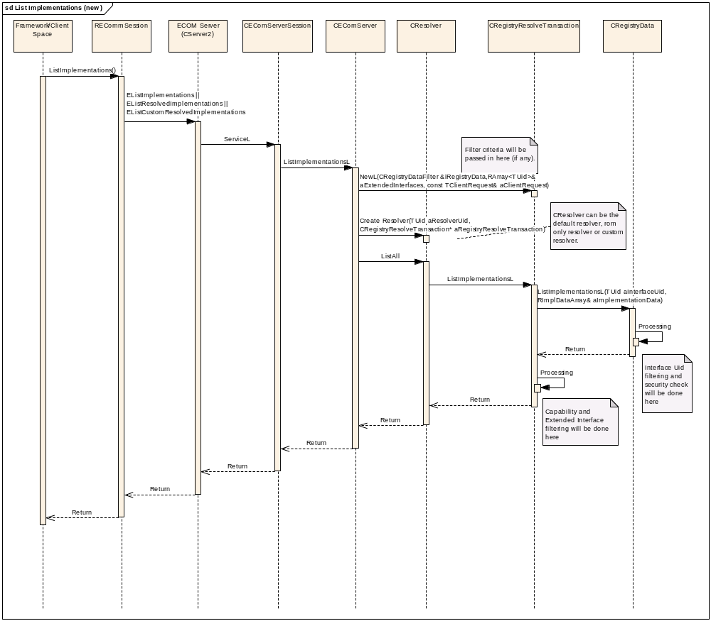
Figure 10 - List Implementations

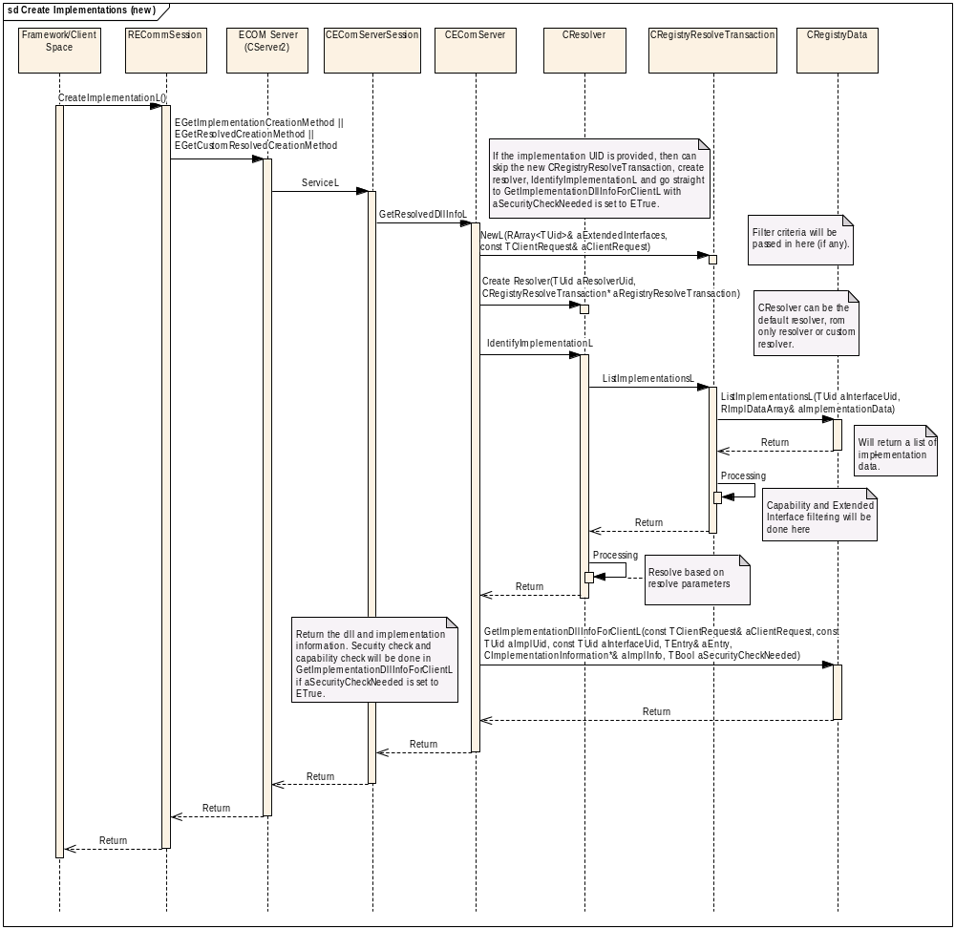
Figure 11 - Create Implementations

CRegistrar
Will handle the parsing of the new resource file format.

CSecurePlugin and CSpiPlugin
TEntry will be populated with KUidInterfaceImplementationCollection3 for UID2 if the resource file format is version 3. This will be used in CRegistryData to verify that the DLL and resource file match.

Design Considerations

Configurability and impact on Master Codeline
Not a configurable feature.

ROM/RAM Memory Strategy

ROM Usage
Very approximately, based on an ARMV5 build, 100 LOC is 300 bytes of ROM usage.
ECOM Client
Class | Approximate LOC required (including comments)
REComSession | 300
CunloadPolicy | 50
CLoadManager | 150
Total | 500

Total ROM usage would increase by 1500 bytes. The original size was 5,860 bytes, so it would be approximately 7,360 bytes after the change. The actual size of ecom.dll becomes 8676 bytes after the change.

ECOM Server
Class | Approximate LOC required (including comments)
EcomServer | 100
CEComServerSession | 100
CRegistrar | 150
CRegistrarData | 200
CSecurePlugin/CSpiPlugin | 50
Total | 600

Total ROM usage would increase by 1800 bytes. The original size was 26120 bytes, so it would be approximately 27,920 bytes after the change. The actual size of ecomserver.exe becomes 29272 bytes after the change.

RAM usage
ECOM Client
Class | Approximate additional RAM requirements
REComSession | None
CunloadPolicy | None
CLoadManager | Each CInstanceInfoSimple requires 12 bytes to hold the implementation proxy row and unload policy.  Each CInstanceInfoExtended requires 48 bytes base + 8 bytes * number of extended interfaces that need releasing  This is part of Run-Time heap usage. It will be released once the implementation object is destroyed.

ECOM Server
Class | Approximate additional RAM requirements
EcomServer | None
CEComServerSession | N bytes+ 4 bytes * number of extended interfaces to search for.  This is part of Run-Time heap usage. N is for other client supplied parameters except extended interface.(eg. ResolverParams)
CRegistrar | None
CRegistrarData | A new pointer points to the RArray that holds extended interface information for each implementation will be in CImplementationInformation (the interface UID, a TUID). So for old plug in, the total RAM usage increase will be 4*X bytes, while for new plug in, the total RAM usage increase will be (4 bytes + 32 + 4 * number of extended interfaces) * Y bytes.  X: Number of old implementations  Y: Number of new implementations with extended interface presented.  This is idle RAM usage.
CSecurePlugin/CSpiPlugin | None

From the above table, the total RAM usage increased in registry data for all of the old plug-ins, without any extended interface, would be 4*No. of implementations bytes. For example, Techview reference UI has 345 plug-in implementations in the ROM image, therefore, the total RAM impact would be 4*345=1380 bytes.

Performance considerations
Low impact to boot time as parsing the new fields should be a small impact. This will be confirmed with performance tests (e.g. with no extended interfaces, 10% techview, 50% etc).

Creating an implementation has low impact, as capability check has been added before returning the list to resolver, which did not exist before (this is actually a defect in itself that is now fixed).

Listing an implementation has low impact, as impact only comes from the filtering on extended interface UIDs.

Getting an extended implementation has low impact, as no look-up is involved, the CInstanceInfo is re-cast appropriately and is immediately used to fetch the extended interface. So it would be similar performance to the GetExtendedMethod pattern outlined in /R1/.

The manual release and automatic release mechanism for extended interfaces is fast, as no searching is required in any data structures. The manual release immediately releases one interface using parameters passed in from the call. The automatic interface only releases extended interfaces that need to be released, and has an array of extended interfaces which are traversed once to release all the extended interfaces.

Destroying an implementation object will have low impact. Some savings will occur as no look up is required to find the implementation object. A low impact will occur to clean up the array element holding the CInstanceInfo element.

Error condition handling
If an extended interface is requested that does not exist, the plug-in code implementer should return NULL, and this will be passed back to the caller.
Invalid extended interface UID’s in any of the operations will be ignored. For any list filtering during Create or List implemenations operations the invalid UID’s will be treated as non-existing, and will be ignored. For get extended interface operations with invalid UID’s it should be treated as a non existent interface and NULL returned by the plug-in code implementer, which would be passed back to the caller.
Validation that the UID2 of the dll and resource file format match will take place. This check will be during a CreateImplementationL operation, and also when discovery is complete. Any mismatch will be logged. See 3.4.3.3 for more details.

Robustness issues
This feature does not have any specific robustness considerations.

Localisation issues
No localisation issues, as their are no language dependencies.

Hardware/Platform assumptions
No hardware/platform issues.

Compatibility considerations (Binary, Source, Data)
There are no compatibility issues as the feature introduces new functionality, and leaves the old functionality as it currently is.

Interoperability considerations
No interoperability issues. No communication with outside device

Platform Security
No changes to ECOM security policy, still based around the DLL loading policies, and no new processes were introduced. Therefore, there are no platform security issues.

Modularity
No modularity issues. Does not directly depend on any other components. But does require a new DLL type, accomplished by the following:
Must rebuild the e32toolp component, after modifying \src\cedar\generic\tools\e32toolp\makmake\_secure_trgtype.pm to include the following entry:

PLUGIN3=>{
'Exports'=>{
MARM=>['ImplementationGroupProxy__FRi'],
EABI=>['_Z24ImplementationGroupProxyRi'],
WINS=>['?ImplementationGroupProxy@@YAPBUTImplementationProxy3@@AAH@Z'],
X86=>['?ImplementationGroupProxy@@YAPBUTImplementationProxy3@@AAH@Z'],
},
ResourcePath=>'Resource\Plugins',
UID2=>'0x10009D93',
},

A new UID2 is required, and will be 0x10009D93.

Testing
Will do unit, component, and performance testing. See component test specification for more details.

Further Information

References
No. | Document Reference | Version | Description
[R1] | N/A | 1.0 | Extending ECom Interfaces
[R2] | SLN.SMG017.008 | 0.10 | Definitive Guide on the Technical Intricacies of Compatibility
[R3] | SGL.TS0017.524 | 1.0 | EC043 Design Sketch

Open Issues
None

Glossary
Term | Definition
Plug-in implementation | The code (implementation) residing in the Plug-in DLL
Plug-in object | Instance of a plug-in
Plug-in DLL | DLL in which the plug-in code resides
Interface Implementation Collection (IIC). | A collection of interfaces with one or more implementations per interface published by a plug-in DLL (within a .RSC file).

If appendices are to be used they should be preceded with a hard page break ( Ctrl+Enter) and the style ‘Appendix Title’ should be used for the Title and ‘Appendix Heading 1, 2 & 3’ styles for the headings within the Appendix (examples are overleaf – if no appendices are to be used, please delete the next page)

Document History
This document is kept and maintained in the ECOM component folder in Perforce:
\src\common\generic\syslibs\ecom\ongoing\documentation\Feature_Documentation
An uncontrolled copy is also held in the Technology Stream folder:
V:\Dev\TS\TS0017 Base Services\RequirementsAnalysis\EngineeringChanges\EC043 - ECOM Interface Versioning
Date | Version | Status | Author | Description
26-11-2007 | 1.4 | Issued | Simon Conway | Minor update to make ListExtendedInterfacesL and ManuallyReleaseExtendedInterfaceL leaving methods. Also added reference to BR2209.
20-08-2007 | 1.3 | Issued | Iris Wu | Updated after review.
26-07-2007 | 1.2 | For Review | Iris Wu | Updated after review.
05-07-2007 | 1.1 | Draft | Aaron Kranabetter | Updated after development.
23-01-2007 | 1.0 | Issued | Aaron Kranabetter | Minor updates to CImplementationInfo.
23-01-2007 | 0.6 | For Review | Aaron Kranabetter | Updated after fourth review.
12-12-2006 | 0.5 | For Review | Aaron Kranabetter | Updated after third review.
05-12-2006 | 0.4 | Draft | Aaron Kranabetter | Updated after second review.
10-11-2006 | 0.3 | Draft | Aaron Kranabetter | Updated after first review.
27-10-2006 | 0.2 | Draft | Aaron Kranabetter | More detail, added further diagrams, incorporated comments from Will Bamberg, Pauline Pan, Simon Chan.
11-10-2006 | 0.1 | Draft | Aaron Kranabetter | First draft.

This allows our current CreateImplementations() to work as they are, that is, there is always only one interface for each implementation. There is never more than one interface for one implementation. So as now, if another instantiable interface is required, a new implementation via an additional implementation_info struct should be created to fulfill this need.
Since each interface/extended interface will have a UID that uniquely identifies the particular interface, it is not necessary to have versions of interfaces, such as v1, v2 etc to identify the interface.

